EIC MICROPROJECT

Topic :- Debate on 42nd, 97th and 103rd Constitutional Amendment Acts of Indian Constitution.


Group Members :-

Danish Solkar (24111590805)

Ayaan Shaikh (24111590810)

Yasir Shaikh (24111590765)

Kalam Khan (24111590782)

INDEX
SR. NO. | TOPIC | PAGE NO. | REMARKS
1. | 42nd Constitutional Amendment Act, 1976 | 3, 4
2. | 97th Constitutional Amendment Act, 2011 | 5, 6
3. | 103rd Constitutional Amendment Act, 2019 | 7, 8

42nd Constitutional Amendment Act, 1976
The 42nd Constitutional Amendment Act, 1976 is one of the most important and also one of the most controversial amendments in the history of the Indian Constitution. It is often called the “Mini Constitution” because it brought about extensive changes.

Background
- Enacted during Emergency (1975–77) under Prime Minister Indira Gandhi.
- Its main aim was to strengthen the central government and reduce the powers of the judiciary.

Major Provisions of the 42nd Amendment
- Preamble Changes
  - Added the words “Socialist”, “Secular” and “Integrity” to the Preamble.
  - The Preamble now reads: “Sovereign, Socialist, Secular, Democratic Republic” and “unity and integrity of the Nation”.
- Fundamental Rights
  - Restricted the power of courts to review constitutional amendments.
  - Made it difficult for courts to strike down laws on grounds of violation of Fundamental Rights.
- Directive Principles of State Policy (DPSP)
  - Gave primacy to DPSPs over Fundamental Rights (in certain cases).
  - Added new DPSPs like:
    - Free legal aid
    - Protection of environment, forests, and wildlife
    - Equal justice and promotion of welfare of workers.
- Fundamental Duties
  - Introduced Article 51A: A new part (Part IVA) listing 10 Fundamental Duties for citizens (e.g., respect the Constitution, protect environment, safeguard public property).
- Judiciary
  - Curtailed the power of judicial review of the Supreme Court and High Courts.
  - Made constitutional amendments immune from judicial review.
- Parliament & Executive
  - Extended the tenure of Lok Sabha and State Assemblies from 5 to 6 years.
  - Empowered Parliament to make laws on any subject in the Concurrent List, giving more power to the Centre.
  - Added provisions to protect laws implementing DPSPs from being challenged in court.
- Emergency Provisions
  - Made the President bound by the advice of the Council of Ministers.
  - Strengthened the Centre’s control during Emergency.

Criticism
- Called authoritarian and against the spirit of democracy.
- Increased centralization of power.
- Reduced independence of the judiciary.
- Weakened the concept of Fundamental Rights.

Later Developments
- The 44th Amendment Act, 1978 (under Janata Government) removed many provisions of the 42nd Amendment:
  - Restored judicial review.
  - Reduced Lok Sabha’s tenure back to 5 years.
  - Restored balance between Fundamental Rights and DPSPs.

In short: The 42nd Amendment Act, 1976 is remembered as the “Mini Constitution” because it made sweeping changes to the Preamble, Fundamental Rights, DPSPs, added Fundamental Duties, curtailed the powers of the judiciary, and strengthened the Central Government—many of which were later reversed.

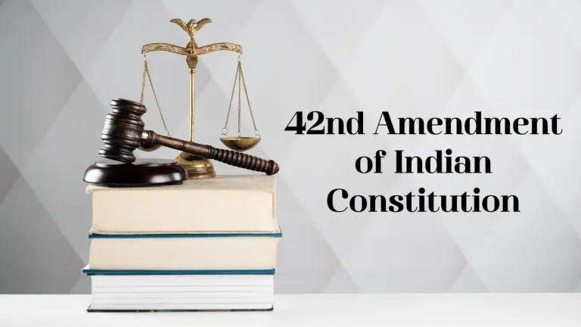

97th Constitutional Amendment Act, 2011
(Came into effect on 15th February 2012)

Purpose
- To promote cooperative societies in India by giving them constitutional status.
- Strengthen democratic functioning and ensure autonomy of cooperatives.

Key Provisions
- Preamble
  - Added the word “Co-operative” after “Socialist, Secular, Democratic, Republic”.
  - Shows importance of the cooperative movement.
- Fundamental Rights (Part III)
  - Inserted Article 19(1)(c): Right to form Co-operative Societies became a Fundamental Right (along with unions & associations).
- Directive Principles of State Policy (Part IV)
  - Added Article 43B: The State shall promote voluntary formation, autonomous functioning, democratic control, and professional management of cooperative societies.
- New Part IXB (Articles 243ZH–243ZT)
  - Gave detailed provisions for Co-operative Societies, similar to Panchayats & Municipalities.
  - Key features:
    - Maximum number of directors: 21.
    - Elections of members within a time-bound manner.
    - Fixed term of 5 years for elected boards.
    - Independent professional management.
    - Audit by professionals.
    - Supersession of a cooperative board allowed only in exceptional cases.

Supreme Court Judgment (2021)
- In Union of India vs Rajendra N. Shah (2021), SC struck down Part IXB insofar as it applied to State cooperatives, saying it violated the federal structure (since “cooperatives” is a State subject under the State List).
- However, provisions relating to Multi-State Co-operative Societies (under Union’s jurisdiction) remained valid.
- Preamble, Article 19(1)(c), and Article 43B still stand.

Significance
- Strengthened the cooperative movement.
- Gave citizens a Fundamental Right to form cooperatives.
- Brought transparency, accountability, and democracy in cooperative functioning.

In short:
The 97th Amendment Act, 2011 gave constitutional recognition to co-operatives, inserted the word “Co-operative” in the Preamble, made forming them a Fundamental Right, added a DPSP (Article 43B), and inserted Part IXB for their governance (partly struck down by SC in 2021).
Here’s a clear, exam-oriented explanation of the 103rd Constitutional Amendment Act, 2019 👇



103rd Constitutional Amendment Act, 2019
(Came into effect on 14th January 2019)

Purpose
- To provide 10% reservation in government jobs and educational institutions to the Economically Weaker Sections (EWS) of citizens other than those covered under existing reservations (SC, ST, OBC).

Key Provisions
- Articles Amended
  - Article 15 (Right to Equality in education)
    - Inserted 15(6): Allows reservation for EWS in educational institutions, including private unaided institutions (except minority institutions).
  - Article 16 (Equality of Opportunity in public employment)
    - Inserted 16(6): Provides up to 10% reservation in jobs for EWS in addition to existing reservations.
- Beneficiaries
  - Citizens belonging to the general category (not covered under SC, ST, OBC quotas) but meeting EWS income & asset criteria.
- Eligibility (as per Govt. Notification)
  - Annual family income less than ₹8 lakh.
  - Landholding below 5 acres.
  - Residential house area: <1000 sq. ft., etc.
  - (Subject to periodic revision).

Significance
- For the first time, reservation in India was given solely on economic basis, not caste/social category.
- Aimed to uplift the poor in the general category.

Supreme Court Verdict (Nov 2022, Janhit Abhiyan v. Union of India)
- Constitutionality of the 103rd Amendment was challenged, arguing it violated the basic structure (by breaching 50% reservation cap and excluding SC/ST/OBC from EWS quota).
- 5-Judge Bench Decision (3:2 majority):
  - Upheld the validity of the amendment.
  - Ruled that economic criteria can be a basis for reservation.
  - Excluding SC/ST/OBC from EWS quota is not discriminatory because they already have reservation benefits.

In Short
The 103rd Amendment Act, 2019 amended Articles 15 & 16 to introduce 10% EWS reservation in education (including private institutions) and public employment, marking a shift by allowing economic criteria as a basis for reservation. It was upheld by the Supreme Court in 2022.

